ish¿u ysñlï weúßKs $ All Rights Reserved

St. Peter's College

St. Peter's College

St. Peter's College

புனித பேதுரு கல்லூரி

புனித பேதுரு கல்லூரி

புனித பேதுரு கல்லூரி

புனித பேதுரு கல்லூரி

புனித பேதுரு கல்லூரி

புனித பேதுரு கல்லூரி

புனித பேதுரு கல்லூரி

புனித பேதுரு கல்லூரி

Ydka; mS;r úÿy,

Ydka; mS;r úÿy,

Ydka; mS;r úÿy,

Ydka; mS;r úÿy,

Ydka; mS;r úÿy,

Ydka; mS;r úÿy,

Ydka; mS;r úÿy,

Ydka; mS;r úÿy,

Ydka; mS;r úÿy,

Ydka; mS;r úÿy,

St. Peter's College

St. Peter's College

St. Peter's College

St. Peter's College

St. Peter's College

St. Peter's College

St. Peter's College

St. Peter's College

St. Peter's College

St. Peter's College

புனித பேதுரு கல்லூரி

புனித பேதுரு கல்லூரி

புனித பேதுரு கல்லூரி

புனித பேதுரு கல்லூரி

புனித பேதுரு கல்லூரி

புனித பேதுரு கல்லூரி

புனித பேதுரு கல்லூரி

புனித பேதுரு கல்லூரி

Ydka; mS;r úÿy,

Ydka; mS;r úÿy,

Ydka; mS;r úÿy,

Ydka; mS;r úÿy,

Ydka; mS;r úÿy,

Ydka; mS;r úÿy,

Ydka; mS;r úÿy,

Ydka; mS;r úÿy,

Ydka; mS;r úÿy,

Ydka; mS;r úÿy,

St. Peter's College

St. Peter's College

St. Peter's College

St. Peter's College

St. Peter's College

St. Peter's College

St. Peter's College

62

E

I,II

**mqrjeis wOHdmkh**

**Civic Education**

**meh folhs**

**Two Hours**

**09 fY%aKsh – úfYaI we.hsu ^m<uq jdrh& - 2022**

**தரம் 09 - விசேட மீளாய்வு (Kjyhk; jtiz) - 2022**

***Grade 09 – Special Evaluation (First Term) - 2022***

Ydka; mS;r úÿy, - fld<U 04

புனித பேதுரு கல்லூரி, கொழும்பு 4

***St. Peter's College - Colombo 04***



Answer all the questions in ***Part I*** and 05 questions from ***Part II***

**Part – I**

01. What is the basic unit in a society,

i. Government ii. Family iii. School iv. Judiciary

02. “Whatever you are, be a good one” Whose saying is this?

i. Kumarathunga Munidasa ii. Rev. Fr. Marceline Jayakodi

iii. Abraham Lincoln iv. George Washington

03. _____________ invented the bulb.

i. Abraham Lincoln ii. George Washington

iii. Thomas Alva Edison iv. Angela Nyawira

04. The methodology man utilizes to make his work easier is known as,

i. Machinery ii. Technology

iii. Sustainable development iv. Infrastruce facilities

05. ‘Dhammo Bhave Rakkhathi Dammachari’ is the motto of,

i. Sri Lanka Army ii. Sri Lanka Navy

iii. Sri Lanka Air Force iv. Sri Lanka Police

06. ‘Building of a just and a law abiding society’ is the vision of,

i. Attorney General’s Department ii. Government Analyst’s Department

iii. Department of Prison iv. Supreme Court

07. What is the governmental body that has been established for the protection of children?

i. Supreme Court ii. Human Rights Commission

iii. National Child Protection Authority iv. Unicef

08. What is the international organization affiliated to the United Nations Organization on behalf of the children?

i. UNICEF ii. UNESCO iii. WHO iv. IMF

09.

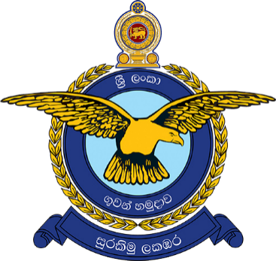

The above picture is the official symbol of,

i. Sri Lanka Army ii. Sri Lanka Air Force

iii. Sri Lanka Navy iv. Sri Lanka Police

10. Who is the chief legal officer of Sri Lanka?

i. Chief Justice ii. Inspector General of Police

iii. Attorney General iv. Secretary of the Defense Ministry

11. ‘The Nation that doesn’t build new things doesn’t rise.’ Who produced this idea?

i. Thomas Alva Edison ii. Abraham Lincoln

iii. Rev. Fr. Marceline Jayakodi iv. Kumarathunga Munidasa

12. Who is considered as the father of the co-operative movement?

i. Robert Owen ii. Angela Nyawira

iii. Robert Andrew iv. Robert Charmes

13. What is the first co-operative credit society of Sri Lanka?

i. Kandy ii. Theldeniya iii. Kundasale iv. Mathale

14. Name an Asian country that has an active co-operative society,

i. Thailand ii. Burma iii. Malaysia iv. Indonesia

15. What is the country where you can see Sumo game?

i. China ii. Japan iii. South Korea iv. Taiwan

16. Who was the Indian leader who encouraged his people to promote the goods made in his own country?

i. Mahatma Gandhi ii. Jawaharlal Nehru

iii. Bal Gangadhar Thilak iv. Surendranath Banerjee

17. _____________ is the main symbol of _____________ culture,

i. Lion , Malaysia ii. Mermaid , Japan

iii. Dragon , Chinese iv. Kimono , Burma

18. What is the organization that has been established to strengthen the co-existence among South Asian country?

i. ASEAN ii. SAARCE iii. OPEC iv. NATO

19.

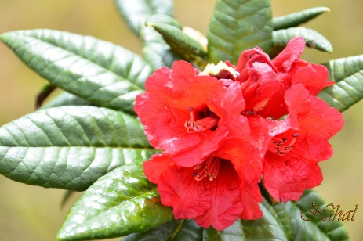

Above is the picture of an endemic plant in Sri Lanka. The plant is,

i. Kekuna ii. Badulla iii. Etamba iv. Maha Rathmal

20.

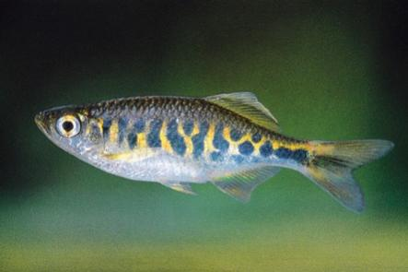

Name the fish specie shown in the above picture,

i. Pathirana Salaya ii. Atissa

iii. Alagoduwa iv. Thilapiya

***(Marks 20 $×$ 2 = 40)***

**Part II**

01. i. Describe what is ‘social security’. ***(03)***

ii. Write 04 responsibilities of the family towards social security. ***(04)***

iii. Write 05 responsibilities of school towards social security. ***(05)***

02. i. Write 03 social institutions that contribute towards social security. ***(03)***

ii. Write 04 responsibilities of religious places towards social security. ***(04)***

iii. Write 05 tasks performed by various social institutions towards social security. ***(05)***

03. i. Write 03 sources of law. ***(03)***

ii. Mention the two ways that the law is being practiced. ***(04)***

iii. Write 05 attributes of laws. ***(05)***

04. i. Write 03 state departments that work in collaboration with the Government Analyst’s Department. ***(03)***

ii. Write 04 responsibilities and duties of individuals relevant to the judiciary. ***(04)***

iii. Write 05 tasks performed by security forces. ***(05)***

05. i. What are the three main processes of economy? ***(03)***

ii. Write 04 contemporary changes that has taken place in the agricultural sector. ***(04)***

iii. Write 05 changes that has occurred in the industrial sector. ***(03)***

06. i. Write 03 qualities of well-being. ***(03)***

ii. Write 04 consequences of not practicing well-being. ***(04)***

iii. How does well-being influence good existence of the society? Write 05 factors. ***(05)***

07. i. Why do we need co-existence in the modern society? Write 03 factors. ***(03)***

ii. Write 04 qualities of co-existence. ***(04)***

iii. Why is it important to promote global co-existence? Write in your own words. ***(05)***